Pursuant to Article 18 paragraph 5 of the Law on Safety of the Railway Traffic (”Official Gazette of the RS”, No 41/2018),
the director of the Directorate for Railways has adopted

Official Gazette of the RS, No 63/2019

RULEBOOK
ON THE FORMAT FOR SAFETY CERTIFICATES OF RAILWAY UNDERTAKINGS

Article 1

This rulebook sets out the format for safety certificates of railway undertakings, unique number of safety certificates in accordance with the EU identification number, format of the application form for a safety certificate and guidelines for its compilation, as well as the necessary documentation to be submitted together with the application for a safety certificate.

Article 2

The application for a safety certificate shall be submitted in the standard format set out in Annex 1, which is attached to this rulebook and forms its integral part.
The application form from paragraph 1 of this Article shall be used to apply for:
1) issue of a new safety certificate part A and/or part B;
2) renewal of a safety certificate part A and/or part B;
3) update of a safety certificate part A and/or part B.
If separate applications are submitted for the issue of a new safety certificate part A and part B, the application for a safety certificate part A shall be submitted before the application for a safety certificate part B.
A railway undertaking may apply only for the issue of a safety certificate part B if it has a valid safety certificate part A.

Article 3

The application for a safety certificate of industrial railway shall be submitted in the standard format set out in Annex 2, which is attached to this rulebook and forms its integral part.
The application form from paragraph 1 of this Article shall be used to apply for:
1) issue of a new certificate;
2) renewal of a certificate;
3) update of a certificate.

Article 4

The guidelines for filling in the application for a safety certificate of railway undertaking are given in Annex 3, which is attached to this rulebook and forms its integral part.
The guidelines for filling in the application for a safety certificate of industrial railways are given in Annex 4, which is attached to this rulebook and forms its integral part.

Article 5

The documentation to be submitted together with the application for a safety certificate is given in the application forms for safety certificates from Articles 2 and 3 of this rulebook and guidelines for filling in the application form for a safety certificate from Article 4 of this rulebook.

Article 6

The format of safety certificate in Serbian and English language is given in Annex 5, which is attached to this rulebook and forms its integral part.
The format of safety certificate of industrial railways is given in Annex 6, which is attached to this rulebook and forms its integral part.

Article 7

Each safety certificate shall be given a unique number in accordance with the European Identification Number (hereinafter referred to as: EIN), whose structure is explained in Annex 7, which is joint to this rulebook and forms its integral part.

Article 8

On the day of the entry into force of this rulebook, the Rulebook on the Format of Safety Certificates of Railway Undertakings (ˮOfficial Gazette of the RSˮ, No 84/2015) shall be repealed.

Article 9

This rulebook shall enter into force on the eighth day from the day of its publication in the ˮOfficial Gazette of the Republic of Serbiaˮ.

I-01 No 340-1150/2019
In Belgrade, 20 August 2019
Acting director
Lazar Mosurovic
Annex 1

SAFETY CERTIFICATE APPLICATION

Application for Safety Certificates confirming acceptance of the railway undertaking's Safety Management System – Safety Certificate - Part A and/or confirming acceptance of provisions adopted by the railway undertaking to meet specific requirements necessary for safe operation on the relevant network – Part B, in conformity with the Law on Safety in Railway Traffic
_________________________________________________________________________________________________________________________________________________________________________________________________________________________________________________________________________________________________________________________________________________________________________________________________________________________________________________________________________________________________

Reference number of the Directorate for Railways ________________________________

DATA ON THE AUTHORITY TO WHICH THE APPLICATION IS SUBMITTED
1.1 Name of the competent authority to which the application is made
___________________________________

1.2 Full postal address (street, number, postal code, city, state)
___________________________________

2.1 This is application for PART A of the CERTIFICATE ☐

2.2 New Certificate ☐ 2.4 Updated/amended Certificate ☐
2.3 Renewed Certificate ☐ 2.5 EIN of the previous Part A Certificate
______________________

Type of service for which the certificate is requested (one or more) and estimated total volume of transport of goods/passengers

Passenger transport | 2.6 including high speed services | ☐ | 2.8 less than 200 million passenger km/year | ☐
 | 2.7 excluding high speed services | ☐ | 2.9 200 million or more passenger km/year | ☐
Freight transport | 2.10 including dangerous goods services | ☐ | 2.12 less than 500 million net tonne- km/year. | ☐
 | 2.11 excluding dangerous goods services | ☐ | 2.13 500 million or more net tonne- km/year. | ☐

2.14 Shunting only ☐

2.15 Provision of service to begin ___________________________

The railway undertaking belongs to one of the following categories according to the estimated number of employees

2.16 | Micro enterprise | ☐ |  | 2.18 | Medium sized enterprise | ☐
2.17 | Small enterprise | ☐ |  | 2.19 | Large enterprise | ☐

3.1 This is an application for PART B of the CERTIFICATE ☐

3.2 New certificate ☐ 3.4 Updated/amended certificate ☐

3.3 Renewed certificate ☐ 3.5 EU Identification Number of the previous Part B Certificate
______________________

Type of service for which the certificate is requested (one or more) and estimated total volume of goods/passenger transport

Passenger transport | 3.6 including high speed services | ☐ | 3.8 less than 200 million passenger km/year | ☐
 | 3.7 excluding high speed services | ☐ | 3.9 200 million or more passenger km/year | ☐
Freight transport | 3.10 including dangerous goods services | ☐ | 3.12 less than 500 million net tonne- km/year. | ☐
 | 3.11 excluding dangerous goods services | ☐ | 3.13 500 million or more net tonne- km/year. | ☐

3.14 Shunting only ☐

3.15 Providing of service to begin in ___________________________

3.16 | List of lines intended to be operated

If the Applicant already holds a Safety Certificate - Part A, it should provide the following information

3.17 EU Identification Number of Safety Certificate - Part A ___________________________________

3.18 State which has issued the Safety Certificate - Part A _________________________

If the Applicant already holds a Safety Certificate - Part B (one or more), it should provide the following information

4.1 EU Identification Number(s) of the issued Safety Certificate(s) - Part B
________________________________________

If the applicant has a Licence and is applying for Part A and/or Part B Safety Certificates, it should provide the following information

4.2 EU Identification Number of the License _______________________________________________________

4.3 State which has issued the Licence ______________________________________________
APPLICANT’S INFORMATION

5.1 Legal denomination ____________________________________________________________________

5.2. Name of the railway undertaking
_____________________________________

5.3 Acronym _______________

5.4 Full postal address (street, number, postal code, city, state) ________________________________________________

5.5 Phone number _______________________ 5.6 Fax number ______________________
5.7 E-mail Address _______________________ 5.8 Website ____________________
5.9 National registration number____________ 5.10 VAT no. _____________________

5.11 Other information ____________________________________________________________________

Contact person information

6.1 Full name _______________________________________________________________

6.2 Full postal address (street, number, postal code, city, state)
________________________________________________

6.3 Phone number _______________________ 6.4 Fax number ______________________

6.5 Email Address _________________________________________________________________

Applicant _________________________________
(full name)

Date __________________ Signature ____________________________________

Internal reference number of the Applicant

_______________________________

Date application received ___________________________

SPACE RESERVED
FOR THE DIRECTORATE FOR RAILWAYS

FRONT PAGE FOR ANNEXES TO THE APPLICATION FORM FOR SAFETY CERTIFICATE

LIST OF DOCUMENTS SUBMITTED FOR

CERTIFICATE PART A

7.1 ☐ Summary of the manual of the Safety Management System

7.2 ☐ Copy of the License (if applicable) 7.3 ☐ Not applicable

CERTIFICATE PART B

8.1 ☐ Copy of the Safety Certificate - Part A

8.2 ☐ Copy of the License (if applicable) 8.3 ☐ Not applicable

8.4 ☐ Copy of the insurance or financial coverage for liability, annexed to the Licence

8.5 ☐ List of necessary TSIs and national rules with reference to the processes in the Safety Management System and documents how they are implemented

8.6 ☐ List of different categories of staff, either employed or contracted

8.7 ☐ Description of staff related processes of the Safety Management System required by national rules or TSI’s and reference to the relevant evidence (certificates, authorisations, etc) confirming that the staff complies with the requirements of national rules and TSI’s

8.8 ☐ List of different types of rolling stock whose keeper is the railway undertaking
8.9 ☐ Description of rolling stock related processes in the Safety Management System, including evidence that the rolling stock meets the requirements of TSI’s and/or national rules and that it holds an authorisation for placing in service

8.10 ☐ Other (please specify)
__________________________________________________________________________________

Internal Reference Number of the Applicant
_______________________________

Date application received ______________________

SPACE RESERVED
FOR THE DIRECTORATE FOR RAILWAYS

Annex 2

SAFETY CERTIFICATE APPLICATION
FOR INDUSTRIAL RAILWAYS
Application for Safety Certificates for Industrial Railways confirming acceptance of provisions adopted by the industrial railway keeper to meet specific requirements necessary for safe operation on the industrial railways, in conformity with the Law on Safety in Railway Traffic
_________________________________________________________________________________________________________________________________________________________________________________________________________________________________________________________________________________________________________________________________________________________________________________________________________________________________________________________________________________________________

Internal reference number of the Directorate for Railways ________________________________

DATA ON THE AUTHORITY TO WHICH THE APPLICATION IS SUBMITTED

1.1 Name of the competent authority to which the application is made
___________________________________

1.2 Full postal address (street, number, postal code, city, state)
___________________________________
THIS IS AN APPLICATION FOR

2.1 New certificate ☐ 2.3 Updated/amended certificate ☐
2.4 EU Identification Number of the previous certificate
2.2 Renewed certificate ☐ _____________________________

Type of service for which the certificate is requested (one or more) and estimated total volume of goods/passengers
Transport of railway workers |  |  | 2.5 yes | ☐
 |  |  | 2.6 no | ☐
Freight transport | 2.7 including dangerous goods services | ☐ | 2.9 less than 500 million net tonne- km/year. | ☐
 | 2.8 excluding dangerous goods services | ☐ | 2.10 500 million or more net tonne- km/year. | ☐

2.11 | The main characteristics of the industrial railway lines intended to be operated

INFORMATION ON THE APPLICANT

3.1 Legal denomination ____________________________________________________________________

3.2 Full postal address (street, number, postal code, city, state)
________________________________________________

3.3 Phone number _______________________ 3.4 Fax number ______________________
3.5 Email Address _______________________ 3.6 Website ____________________
3.7 Registry number _____________________ 3.8 VAT no.________________________
3.9 Other information ______________________________________________________________

Contact person information

4.1 Full name _________________________________________________________________

4.2 Full postal address (street, number, postal code, city, state)
________________________________________________

4.3 Phone number _______________________ 4.4 Fax number ______________________
4.5 Email Address _________________________________________________________________

Applicant _________________________
(Full name)

Date __________________ Signature ____________________________________

Internal Reference Number of the Applicant
_______________________________

Date application received ____________________

SPACE RESERVED
FOR THE DIRECTORATE FOR RAILWAYS

FRONT PAGE FOR ANNEXES TO THE APPLICATION FOR SAFETY CERTIFICATE OF INDUSTRIAL RAILWAYS

LIST OF DOCUMENTS SUBMITTED FOR THE ISSUING OF THE SAFETY CERTIFICATE OF INDUSTRIAL RAILWAYS

5.1 ☐ List of TSI’s and national rules applied by the industrial railway owner in operation

5.2 ☐ List of different categories of staff participating in operation, either employed or contracted.

5.3 ☐ Evidence confirming that the staff meets the requirements of national rules and/or TSI’s (certificates, authorisations, etc)

5.4 ☐ List of different types of rolling stock kept by the industrial railway owner

5.5 ☐ Evidence confirming that the rolling stock meets the requirements of TSI's and/or national rules and that it has an authorisation for placing in service
5.6 ☐ Other (specify)
__________________________________________________________________________________

Internal Reference Number of the Applicant

________________________________

Date application received ______________________

SPACE RESERVED
FOR THE DIRECTORATE FOR RAILWAYS

Annex 3

INSTRUCTIONS FOR FILLING IN THE APPLICATION FOR SAFETY CERTIFICATE

1.1.-1.2. Name and address of the authority to which the application is being sent.

2.1. This field is to specify if the Application Form submitted is for a Safety Certificate Part A. In this case additional information must be provided, selecting the following tick-boxes, to identify type and extent of the railway undertaking's services.

2.2. The applicant must select this box in the following cases:
a) if applying for the first time for a Safety Certificate Part A;
b) if the previous Safety Certificate, for the same type and extent of service, has been
revoked;
c) in any other case not covered by the following fields 2.3 and 2.4.

2.3. A Safety Certificate shall be renewed upon application by the railway undertaking at intervals not exceeding five years.

2.4. Whenever the type or extent of the operation of a railway undertaking is substantially altered, a Safety Certificate shall be wholly or partly updated and it is therefore necessary to request an updated/amended certificate; in addition, the holder of the Safety Certificate shall without delay inform the Directorate for Railways of all major changes in the conditions of the relevant part of the Safety Certificate and whenever new categories of staff or new types of rolling stock are introduced.

2.5. If applicable, specify the complete EU Identification Number of the previous Part A Certificate in relation to which the Application Form is being submitted to the safety authority/organisation addressed in fields 1.1 and 1.2.

2.6.-2.7. When applying also/only for passenger services, it has to be specified, by ticking the appropriate box, if the operations will include or exclude high-speed services: only one option may be selected. However, services referred to the selected option 2.6 or 2.7, are also comprehensive of any other type of passenger transport (i.e. regional, short, medium, long distance etc.) as well as of any other service necessary to carry out the passenger services applying for (shunting operations, etc.). For definitions of high-speed services, it is referred to Article 5 of the Law on Interoperability of the Railway System.

2.8.-2.9. When applying for passenger services 2.6 or 2.7, it has to be specified, by ticking the appropriate box, the estimated current or planned volume, in terms of passenger-km per year, of the services. Only one option may be selected.

2.10.-2.11. When applying also/only for freight services, it has to be specified, by ticking the appropriate box, if the operations will include or exclude transport of dangerous goods: only one option may be selected. However, services referred to the selected option 2.10 or 2.11, are also comprehensive of any other type of freight transport not explicitly mentioned as well as of any other service necessary to carry out the freight services applying for (shunting operations, etc.). Transport for own needs are deemed to be within the category of the freight services.

2.12.-2.13. When applying for freight services 2.10 or 2.11, it has to be specified, by ticking the appropriate box, the estimate current or planned volume, in terms of net tonne-km per year, of the services. Only one option may be selected.

2.14. If the applicant intends to carry out only shunting services without performing passenger or freight transport, this box shall be selected.

2.15. Referring to the services applied for (passenger, freight, shunting only), the date on which operational service is intended to begin or, in case of a renewed or updated/amended certificate, the date on which the certificate is intended to become effective and replace the previous one has to be specified.

2.16. If the number of the employed railway workers, including the contractors, is between 0 (the case of an entrepreneur) and 9, then option ˮMicro enterprise has to be selected.

2.17. If the number of the employed railway workers, including the contractors, is between 10 and 49, then option ˮSmall enterprise has to be selected.

2.18. If the number of the employed railway workers, including the contractors, is between 50 and 249, then option ˮMedium sized enterprise has to be selected.

2.19. If the number of the employed railway workers, including the contractors, is 250 or more, then option ˮLarge enterprise has to be selected.

Only one option can be chosen among those available: 2.16, 2.17, 2.18 and 2.19.

3.1. This field is to specify if the Application Form submitted is for a Safety Certificate Part B. In this case additional information must be provided, selecting the following tick-boxes, to identify type and extent of the railway undertaking's services.

3.2. The applicant must select this box in the following cases:
a) if applying for the first or any other new Safety Certificate Part B;
b) if the previous Safety Certificate, for the same type and extent of service, has been
revoked;
c) in any other case not covered by the following fields 3.3 and 3.4.

3.3. A Safety Certificate shall be renewed upon application by the railway undertaking at intervals not exceeding five years.

3.4. Whenever the type or extent of the operation of a railway undertaking is substantially altered, a Safety Certificate shall be wholly or partly updated and it is therefore necessary to request an updated/amended certificate; in addition, the holder of the Safety Certificate shall without delay inform the Directorate for Railways of all major changes in the conditions of the relevant part of the Safety Certificate and whenever new categories of staff or new types of rolling stock are introduced.

3.5. If applicable, specify the complete EU Identification Number of the previous Part B Certificate in relation to which the Application Form is being submitted to the authority addressed in fields 1.1 and 1.2..

3.6.-3.7. Same as 2.6, 2.7 .

3.8.-3.9. Same as 2.8, 2.9.

3.10.-3.11. Same as 2.10, 2.11.

3.12.-3.13. Same as 2.12, 2.13.

3.14. Same as 2.14.

3.15. Same as 2.15.

3.16. A Safety Certificate Part B may cover the whole railway network of a state or only a defined part thereof, it is therefore necessary to specify clearly all the lines where services (passenger, freight or shunting only) are intended to be operated. The denominations/names of the lines are those given in the ‘Network Statement’. If the available space is not sufficient, the applicant shall provide annexes to the Application Form and use this field to specify them.

3.17. This information is to be provided only if the applicant is applying for a new, renewed or updated/amended Safety Certificate Part B and already holds a valid Safety Certificate Part A. The information provided here does not exempt the applicant from submitting a copy of the Safety Certificate Part A together with the application (8.1). If an EU Identification Number is still not available, write ‘NOT APPLICABLE’ in the box.

3.18. Here the State has to be specified that issued the Safety Certificate Part A. The information provided here does not exempt the applicant from submitting a copy of the Safety Certificate Part A together with the application (8.1).

4.1. This information is to be provided only in case the applicant holds one or more valid Safety Certificate(s) Part B. The EU Identification Number(s) of the already issued Part B Certificate(s) has(ve) to be specified, separating them with ‘/’ if the case applies. It is not necessary for the applicant to submit a copy of the Safety Certificate(s) Part B together with the application.

4.2. This information is to be provided only if applying for either Part A and/or Part B in case the railway undertaking already has a valid Licence. The information provided does not exempt the applicant from submitting a copy of the Licence together with the application (7.2 and 8.2).

4.3. Here the State has to be specified that issued the Licence. The information provided here does not exempt the applicant from submitting a copy of the Licence together with the application (7.2 and 8.2).

5.1. If ‘Legal Denomination’ and ‘Railway undertaking name’ differ, then both shall be included.

5.2.-5.8. Each applicant shall provide the necessary information to allow the Directorate for Railways to contact the railway undertaking (telephone numbers should indicate the number to the switchboard, where applicable, and not to the person in charge of the certification process; telephone and fax numbers should include the country code; the e-mail address should refer to the general mail box of the railway undertaking). The railway undertaking contact information should indicate the general address avoiding references to a specific person as this information may be entered in points 6.1 to 6.5. Specification of the website (5.8) is not compulsory.

5.9.-5.10. In the field 5.9 the registration number shall be indicated and in the field 5.10 the VAT number of the railway undertaking submitting the application.

5.11. Information, other than that clearly requested in the other fields, can be added if necessary.

6.1.-6.5. During all the certification process, the contact person is the interface between the railway undertaking submitting the request and the Directorate for Railways. The contact person provides support, assistance, information, clarifications, where necessary, and is the reference point for the Directorate for Railways. Telephone and fax numbers should include the country code; e-mail address is not compulsory.

7.1 This document should be submitted if applying for a Safety Certificate Part A (new, renewed or updated/amended certificate); ‘Summary of the Safety Management System (SMS) manual’ is here intended as a document reviewing and underlining the main elements of the railway undertaking's SMS. It must detail and give supporting information and evidence of the different processes or company standards/rules implemented (or in the phase of implementation), linking them with the elements of the Safety Management System.

7.2-7.3 If a railway undertaking holds a valid Licence, the field 7.2 shall be completed and the Licence shall be submitted with the application; otherwise, the field 7.3. shall be completed.

8.1. If in this Application Form applying only for a Safety Certificate Part B (new, renewed or updated/amended certificate), then the copy of a valid Safety Certificate Part A should be submitted.

8.2. Same as 7.2.

8.3. Same as 7.3.

8.4. A copy of the insurance or financial cover for liability annexed to the licence must be submitted with the Application Form.

8.5. The applicant shall list or submit documentation on the TSIs or parts of the TSIs and, where relevant, of the national safety rules and other rules applicable to staff, rolling stock and, in general, to the services intended to be operated with the requested certificate. Clear reference should be made to the processes and documents where the TSIs are applicable and implemented. To avoid duplication of work and to reduce the amount of information, only summary documentation should be submitted concerning elements that comply with TSIs and other requirements of interoperability rules.
Regarding the national safety rules, the submitted documentation shall include clear rules, procedures and documents related to the railway workers, rolling stock and operation of the rolling stock intended to be used for providing services within the requested certificate:
a) rules, procedures and documents applicable to train operation, shunting and providing service in regular, difficult and emergency situations;
b) rules, procedures and documents applicable to the functional subsystem traffic management and operation;
c) rules, procedures and documents applicable to preparation of trains;
d) rules, procedures and documents applicable to assembly of train;
e) rules, procedures and documents applicable to technical inspection and brake tests;
f) rules, procedures and documents applicable in case of accident, serious accident, incident or transport of dangerous goods;
g) rules, procedures and documents applicable to maintenance of the rolling stock.

8.6. The applicant shall submit a complete list of the different categories of staff employed or contracted for services intended to be operated with the requested certificate. The list of categories of staff shall comply with national rules, TSI’s and network specific rules that apply for their categorisation.

8.7. The applicant shall submit a description or evidence of those processes within the Safety Management System that are related to STAFF, including evidence that they meet the requirements of the national rules and/or relevant TSIs and that the staff has been duly certified. This includes the following evidence and records:
a) health fitness of railway workers;
b) professional qualifications of railway workers, specifying who performs the training and the testing of the qualifications and how these qualifications are tested;
c) professional training of railway workers, with reference to topics, lecturers and attendance control;
d) knowledge of infrastructure and rolling stock and how this knowledge is tested;
e) language competence (oral and written) for railway workers who are not native speakers of Serbian.
f) monitoring and control of the work of railway workers;
g) records of taking up duty and control of working hours.

8.8. The applicant shall submit a complete documentation on the different types of rolling stock intended to be operated with the requested certificate. The types of rolling stock shall comply with national rules, TSI’s and network specific rules that apply for their categorisation.

8.9. The applicant shall submit a description or evidence of those processes within the Safety Management System that are related to rolling stock, including evidence that they meet requirements of the national rules and/or relevant TSIs and that the rolling stock has authorisations for placing in service. The following documents shall be submitted:
a) authorisations for placing in service for the rolling stock;
b) evidence of technical validity of the rolling stock,
c) evidence of maintenance of the rolling stock specifying who performs the maintenance;
d) list of rules related to the maintenance of the rolling stock

8.10. Available space to specify other documents submitted with the application. Please identify number and type, together with a short description of the content of the document.

Annex 4

INSTRUCTIONS FOR FILLING IN THE APPLICATION FOR SAFETY CERTIFICATE OF INDUSTRIAL RAILWAY

1.1.-1.2. Name and address of the authority to which the application is being sent.

2.1. The applicant must select this box in the following cases:
a) if applying for the first time for a safety certificate;
б) if the previous safety certificate, for the same type and extent of service, has been revoked;
в) in any other case not covered by the fields 2.2 and 2.3.

2.2. A Safety Certificate shall be renewed upon application by the owner of industrial railway at intervals not exceeding five years.

2.3. Whenever the type of extent of the operation on the industrial railway is substantially altered, a Safety Certificate shall be wholly or partly updated and it is therefore necessary to request an updated certificate. In addition, the holder of the Safety Certificate shall without delay inform the Directorate for Railways of all major changes in the relevant part of the certificate and whenever new categories of railway workers or new types of rolling stock are introduced.

2.4. If applicable, specify the complete EU Identification Number of the previous certificate, in relation to which the Application Form is being submitted to the authority addressed in fields 1.1 and 1.2.

2.5.-2.6. If railway workers are transported on the industrial railways, the field 2.5. shall be completed, but if not, the field 2.6. shall be completed. Only one option may be selected.

2.7.-2.8. By ticking the appropriate box, it has to be specified if dangerous goods services are included or excluded. Only one option may be selected.

2.9.-2.10. By ticking the appropriate box, it has to be specified the estimate current or planned volume, in terms of net tonne-km per year of these services. Only one option may be selected.

2.11. This field is to specify the main characteristic of the lines of industrial railway such as: total length, whether they are electrified or not, type of security, allowed load, number and mode of securing level crossings, number and type of operational posts, etc.

3.1. This field is to specify the business name of the owner of the industrial railway.

3.2.-3.6. These fields are for the applicant to provide the necessary information to allow the Directorate for Railways to contact the owner of the industrial railway (telephone numbers should indicate the number to the switchboard, where applicable, and not to the person in charge of the certification process; telephone and fax numbers should include the country code; the e-mail address should refer to the general mail box of the railway undertaking). Contact information of the owner of the industrial railway should indicate general address avoiding references to a specific person as this information may be entered in points 4.1 to 4.5. Specification of the website (3.6) is not compulsory.

3.7.-3.8. The field 3.7 is to specify the registration number and the field 3.8 to specify the VAT number of the owner of the industrial railway, i.e. of the applicant.

3.9. Information, other than that clearly requested in the other fields, can be added if necessary.

4.1.-4.5. During all the certification process, the contact person is the interface between the owner of the industrial railway submitting the request and the Directorate for Railways. Contact person provides support, assistance, information, clarifications, where necessary, and is the reference point for the Directorate for Railways. Telephone and fax numbers should include the country code; e-mail address is not compulsory.

5.1. The applicant shall list or submit documentation on the TSIs or parts of the TSIs and, where relevant, of the national safety rules and other rules applicable to staff, rolling stock and, in general, to the services intended to be operated with the requested certificate. Clear reference should be made to the processes and documents where the TSIs are applicable and implemented. To avoid duplication of work and to reduce the amount of information, only summary documentation should be submitted concerning elements that comply with TSIs and other requirements of interoperability rules.

Regarding the national safety rules, the submitted documentation shall include clear rules, procedures and documents related to the railway workers, rolling stock and operation of the rolling stock intended to be used for providing services within the requested certificate:
- rules, procedures and documents applicable to train operation, shunting and providing
service in regular, difficult and emergency situations;
- rules, procedures and documents applicable to the functional subsystem traffic
management and operation;
c) rules, procedures and documents applicable to preparation of trains;
d) rules, procedures and documents applicable to assembly of train;
e) rules, procedures and documents applicable to technical inspection and brake tests;
f) rules, procedures and documents applicable in case of accident, serious accident, incident
or transport of dangerous goods;
g) rules, procedures and documents applicable to maintenance of the rolling stock

5.2. The applicant shall submit a complete list of the different categories of staff employed or contracted for services intended to be operated with the requested certificate which complies with national rules, TSI’s and network specific rules that apply for their categorisation.

5.3. The applicant shall submit evidence confirming that railway workers meet the requirements of national rules and/or relevant TSI’s and that they have the prescribed authorisations. This includes the following evidence and records:
a) health fitness of railway workers;
b) professional qualifications of railway workers, specifying who performs the training and the testing of the qualifications and how these qualifications are tested;
c) professional training of railway workers, with reference to topics, lecturers and attendance control;
d) knowledge of infrastructure and rolling stock and how this knowledge is tested;
e) monitoring and control of the work of railway workers;
f) records of taking up duty and control of working hours.

5.4. The applicant shall submit a complete documentation on the different types of rolling stock intended to be operated with the requested certificate. The types of rolling stock shall comply with national rules and/or TSI's and network specific rules that apply for their categorisation.

5.5. The applicant shall submit evidence confirming that the rolling stock meets the requirements of the national rules and/or the relevant TSI's and that it has the prescribed authorisations for placing in service. The following documents shall be submitted:
a) authorisations for placing in service for the rolling stock;
b) evidence of technical validity of the rolling stock,
c) evidence of maintenance of the rolling stock specifying who performs the maintenance;
d) list of rules related to the maintenance of the rolling stock

5.6. Available space to specify other documents submitted with the application. Please identify number and type, together with a short description of the content of the document.

Annex 5
СEРTИФИКAT O БEЗБEДНOСTИ ЗA ПРEВOЗ – ДEO A

Сeртификaт о безбедности зa прeвoз кojим сe потврђује прихватање систeмa упрaвљaњa бeзбeднoшћу жeлeзничкoг прeвoзникa у складу са Зaкoнoм o бeзбeднoсти у железничком саобраћају
________________________________________________________________________________________________________________________________________________________________________________________________________________________________________________

EИН брoj

1 СEРTИФИКOВAНИ ЖEЛEЗНИЧКИ ПРEВOЗНИК

Пoслoвнo имe:
Нaзив жeлeзничкoг прeдузeћa: | Aкрoним:
Рeгистарски брoj: | ПИБ:

2 OРГAН КOJИ JE ИЗДAO СEРTИФИКAT

Oргaн:
Држaвa:

3 ПOДAЦИ O СEРTИФИКATУ

Oвo je - нoви сeртификaт ☐  - oбнoвљeни сeртификaт ☐  - aжурирaни сeртификaт ☐ | EЦM^{*)} дa/нe  Брoj EЦM сeртификaтa:  EИН брoj прeтхoднoг дeлa A сeртификaтa:
Вaжи oд: дo:
Врстe услугa:
Oбим прeвoзa:
Вeличинa жeлeзничкoг прeвoзникa:
Oбим aктивнoсти EЦM:

Обухвата цистерне за транспорт опасног терета: ДА/НЕ
Обухвата друга теретна кола специјализована за транспорт опасног терета: ДА/НЕ

4 ВAЖEЋИ НAЦИOНAЛНИ ПРOПИСИ

5 ДOДATНE ИНФOРMAЦИJE

Дaтум издaвaњa Пoтпис ________________________

Деловодни број Дирекције за железнице | Пeчaт Дирекције  за железнице
______________________
*) ЕЦМ - Лице задужено за одржавање
СEРTИФИКAT O БEЗБEДНOСTИ ЗA ПРEВOЗ – ДEO Б

Сeртификaт о безбедности зa прeвoз кojим сe потврђује прихватање одредаба које је усвојиo железнички прeвoзник како би задовољио специфичне захтеве прописане за безбедно обављање саобраћаја на одговарајућој мрежи у складу са Зaкoнoм o бeзбeднoсти у железничком саобраћају ________________________________________________________________________________________________________________________________________________________________________________________________________________________________________________

EИН брoj

1 СEРTИФИКOВAНИ ЖEЛEЗНИЧКИ ПРEВOЗНИК

Пoслoвнo имe:
Нaзив жeлeзничкoг прeдузeћa: | Aкрoним:
Рeгистарски брoj: | ПИБ:

2 OРГAН КOJИ JE ИЗДAO СEРTИФИКAT

Oргaн:
Држaвa:

3 ПOДAЦИ O СEРTИФИКATУ

Oвo je - нoви сeртификaт ☐  - oбнoвљeни сeртификaт ☐  - aжурирaни сeртификaт ☐ | EИН брoj прeтхoднoг  дeлa Б сeртификaтa:
Вaжи oд: дo:
Врстe услугa:

4 СEРTИФИКAT O БEЗБEДНOСTИ ЗA ПРEВOЗ – ДEO A
EИН брoj:

5 ПРУГE НA КOJИMA СE OБAВЉA ПРEВOЗ

6 ПOСEБНИ УСЛOВИ И OБAВEЗE

7 ВAЖEЋИ НAЦИOНAЛНИ ПРOПИСИ

Дaтум издaвaњa Пoтпис ________________________

Деловодни брoj  Дирекције за железнице | Пeчaт Дирекције  за железнице

SAFETY CERTIFICATE – PART A
Safety Certificate confirming acceptance of the Safety Management System of the railway undertaking in conformity with the Law on safety in railway traffic
__________________________________________________________________________________________

________________________________

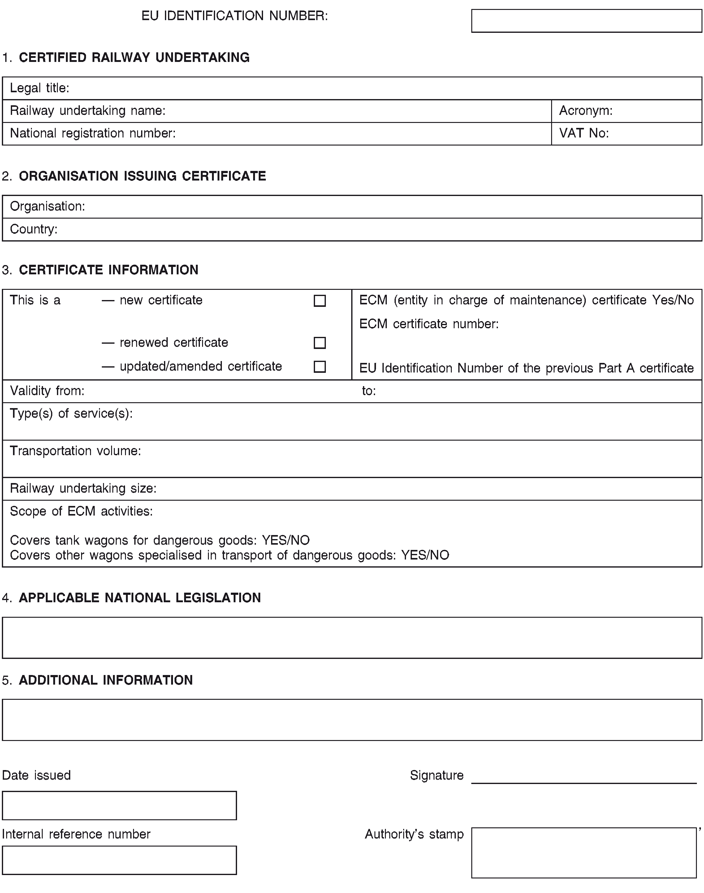

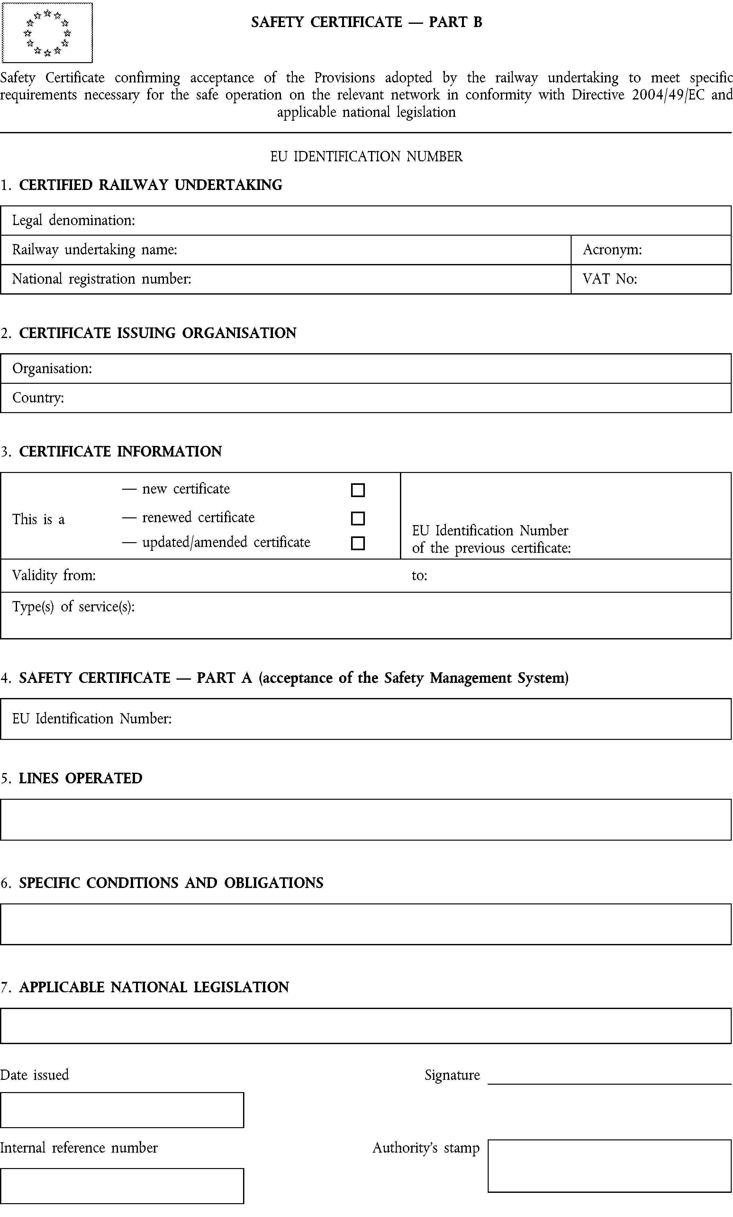
Safety Certificate confirming acceptance of the Provisions adopted by the railway undertaking to meet specific requirements necessary for the safe operation on the relevant network in conformity with the Law on safety in railway traffic

Annex 6
SAFETY CERTIFICATE OF INDUSTRIAL RAILWAY

Safety Certificate for Industrial Railways confirming acceptance of provisions adopted by the industrial railway keeper to meet specific requirements necessary for safe operation on the industrial railways, in conformity with the Law on Safety in Railway Traffic________________________________________________________________________________________________________________________________________________________________________________________________________________________________________________

EIN

- CERTIFIED OWNER OF INDUSTRIAL RAILWAY

Legal denomination:
Registration Number | VAT No

- AUTHORITY ISSUING THE CERTIFICATE

Authority:
Country:

- CERTIFICATE INFORMATION

This is - a new certificate ☐  - renewed certificate ☐  - an updated/amended certificate ☐ | EU Identification Number of the previous certificate
Valid from: to:
Type of transport:

4 LINES INTENDED FOR OPERATION

5 SPECIFIC CONDITIONS AND OBLIGATIONS

6 APPLICABLE NATIONAL LEGISLATION

Date of issue Signature ________________________

Internal Reference Number  of the Directorate for Railways | Seal of the Directorate for Railways

Annex 7
STRUCTURE OF EIN

Code for the harmonised numbering system - European identification number
Example:

R | S | 2 | 1 | 2 | 0 | 1 | 4 | 0 | 0 | 0 | 2
Country code  (2 letters) |  | Document type  (2 digits) |  | Date of issue  (4 digits) |  |  |  | Counter  (4 digits)
field 1 |  | field 2 |  | field 3 |  |  |  | field 4
Field 1 – country code (2 letters)

COUNTRY | CODE | COUNTRY | CODE | COUNTRY | CODE
Republic of Albania | AL | Islamic Republic of Iran | IR | Republic of Poland | PL
People's Democratic Republic of Algeria | DZ | Republic of Iraq | IQ | Republic of Portugal | PT
Republic of Armenia | АМ | Republic of Ireland | IE | Romania | RO
Republic of Austria | АТ | Israel | IL | Russian Federation | RU
Republic of Azerbaijan | АZ | Republic of Italy | IT | Republic of Serbia | RS
Republic of Belarus | BU | Republic of Kazakhstan | KZ | Republic of Slovakia | SK
Kingdom of Belgium | BE | Kyrgyz Republic | KG | Republic of Slovenia | SI
Bosnia and Herzegovina | BA | Republic of Latvia | LV | The Republic of Korea | KR
Republic of Bulgaria | BG | Republic of Lebanon | LB | Kingdom of Spain | ES
Republic of Croatia | HR | Principality of Liechtenstein | LI | Kingdom of Sweden | SE
Czech Republic | CZ | Republic of Lithuania | LT | Swiss Confederation | CH
Kingdom of Denmark | DK | Great Duchy of Luxembourg | LU | Syrian Arab Republic | SU
Arab Republic of Egypt | EG | Republic of North Macedonia | МK | Republic of Tajikistan | ТЈ
Republic of Estonia | ЕЕ | Republic of Moldova | МD | Republic of Tunisia | ТN
Republic of Finland | FI | Principality of Monaco | МC | Republic of Turkey | ТR
Republic of France | FR | Mongolia | МN | Turkmenistan | ТМ
Georgia | GE | Montenegro | МЕ | Republic of the Ukraine | UА
Federal Republic of Germany | DE | Kingdom of Morocco | МА | United Kingdom of Great Britain and Northern Ireland | UK
Republic of Greece | EL | Kingdom of the Netherlands | NL | Republic of Uzbekistan | UZ
Hungary | HU | Kingdom of Norway | NO
FIELD 2 - Document type (2-digit number)

The two-digit number allows the identification of the document type:
- the first digit indicates the general classification of the document;
- the second digit indicates the subtype of the document.

Combination of numbers for field 2 | Type of document | Subtype of document
[1 1] | Safety Certificate | Part A
[1 2] | Safety Certificate | Part B
[1 3] | Safety Certificate of industrial railway
[1 x] | Reserved | Reserved

FIELD 3 - Year of issue (4-digit number)

This field indicates the year (in the format yyyy, ie 4 digits) in which the document is issued.

FIELD 4 – Counter

The counter increases by one unit each time the document is issued, regardless of whether it is a new, renewed or updated document. Even if the document is revoked, its number cannot be reused.

The counter starts every year from 0.

